How
do I
improve my consent’s

“readability”, or lower its
“reading level”?

One of the ethical obligations we have as researchers is to obtain informed consent from our subjects. Though consent documentation is but one part of the consent process, it is an important one, and we need to make sure that all subjects can use the information in the consent document to inform themselves of the research in which they are being asked to participate. One aspect of this obligation is to ensure that the

reading level of the document is appropriate for TCNJ IRB requires that the audience.
the audience. To standardize this requirement the

- all documentation for the general public
be written at a 6th grade level (or lower)

- all documentation for undergraduates be written at a 12th grade level (or lower)
- all documentation for children be written at or below the grade level of the population.

How do I determine my document’s reading level?
The IRB uses Microsoft Word’s grammar checker to quantify reading level. But by default, MS Word

does not check for readability when you check for grammar and spelling. that:
You have to tell it to. To do

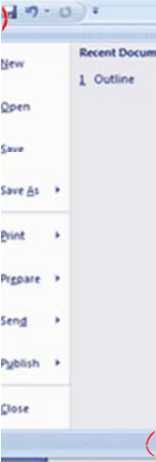
for Word 2007
Step 1

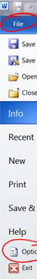
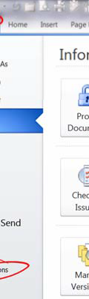
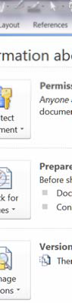
for Word

2010

Click the “Orb” in the top left corner, then select ‘Word Options’ on the bottom of the tab that opens.

Go to the ‘File’ menu/ribbon and select ‘Options’ (lower left-hand side under ‘Help’.)

Subsequent steps are identical in both Word versions.

Step 2

Select ‘Proofing’ in the dialog that pops up; scroll down to view the “When correcting spelling and grammar in Word” area, and make sure the “Check readability statistics” box is checked.

(If you do this in Word without having a particular document loaded, it should make this the default setting for all new

documents you create. readability.)

Step
Word does not by default check

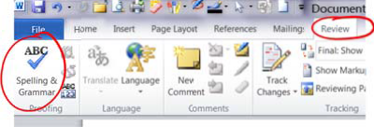
3

Now that Word is set to check readability statistics, select the ‘Review’ Menu ribbon, and select ‘Spelling & Grammar’ on the left side of the ribbon. Word will now check grammar and

spelling throughout th
document, and ask you to approve its

suggested revisions. (Most of the time, it does a good job with this…)

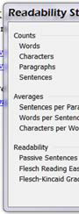
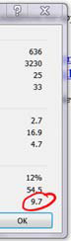
Step 4

After it completes checking spelling & grammar, it will display a dialog box with readability statistics. The relevant number is the “Flesch- Kincaid Grade Level”. (The box on the left is reporting the statistics from this document.)

How do I improve my ‘score’?
The F-K number is based on simple measures of word and sentence complexity. (See
http://en.wikipedia.org/wiki/Flesch-Kincaid_Readability_Test#Flesch.E2.80.93Kincaid_Grade_Level for

details.)
The remedy to a high score is to shorten sentences and reduce word complexity. Some ways to

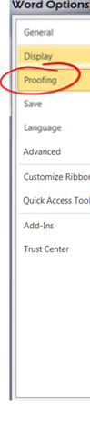
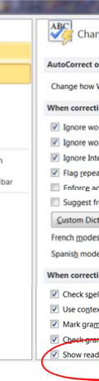
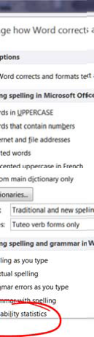
do this include eliminating or moving clauses, reducing passive verb use, and avoiding jargon or sophisticated vocabulary.

For example, “If you consent to participate in this research study you will have the opportunity to ask any additional questions you may have as well as withdraw from the study at any time” (F-K grade level of 15.3) might be rephrased as “Even after you agree to be in the study, you can ask questions about it at any time. You may also stop participating whenever you like.” (F-K grade level of 7.6.)

Consider the level of detail, and the use of technical or discipline-specific vocabulary. Even if such jargon can be used while keeping your score low, we may require that you revise it. (That is: an appropriate F-K grade level is a necessary but not sufficient condition for approval.) More help (especially for more complex consents) is available on the web:

- http://www.templehealth.org/ICTOOLKIT/html/ictoolkitpage16.html
- http://www.grouphealthresearch.org/capabilities/readability/readability_home.html

If you need more help understanding this requirement, or how to meet it, please contact the IRB at
irb@tcnj.edu and we will try to help.

